

Digital Notes

(Subject Name:- Operating Systems)
(Subject Code :- BCA-2003T)
BCA
1st year

1) Definition of Operating System
An Operating System is system software that acts as an interface between the user and the computer hardware. It manages all hardware and software resources and provides an environment for program execution.
Key ideas behind the definition
- Acts as a bridge between user and hardware
- Controls CPU, memory, storage, and I/O devices
- Ensures programs run efficiently
- Provides protection and coordination
- Called a resource manager because it allocates and tracks system resources

2) Parts of an Operating System
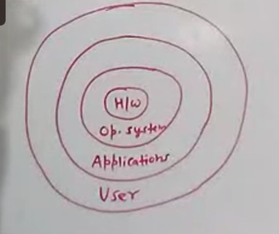
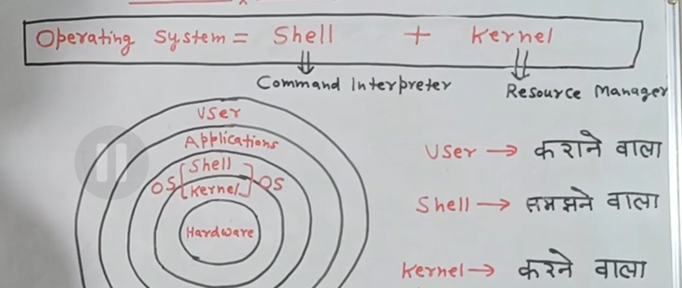
A) Shell (Command Interpreter)
The shell is the outer layer of the OS that interacts with users.
Functions
- Accepts commands from user
- Interprets instructions
- Sends requests to kernel
- Displays output/results
Purpose
- Makes system easy to use
- Converts user language → machine actions
Flow
User → Shell → Kernel → Hardware

B) Kernel
The kernel is the core component of the OS that directly controls hardware.
Responsibilities
- Process scheduling
- Memory allocation
- Device communication
- File system handling
- System protection
Why kernel is important
- Central decision maker
- Coordinates all operations
- Maintains system stability
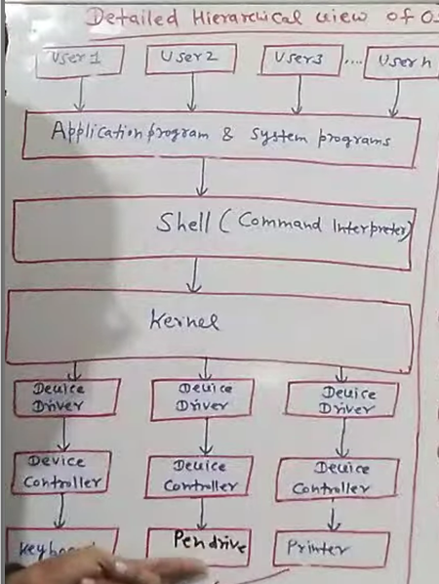

3) Examples of Operating Systems
Common operating systems include:
- Microsoft Windows — desktop & enterprise systems
- Linux — open-source multiuser OS
- UNIX — foundational multiuser OS
- MS-DOS — early single-user OS

4) Components / Functions of Operating System
This section expands your raw points into structured explanations.
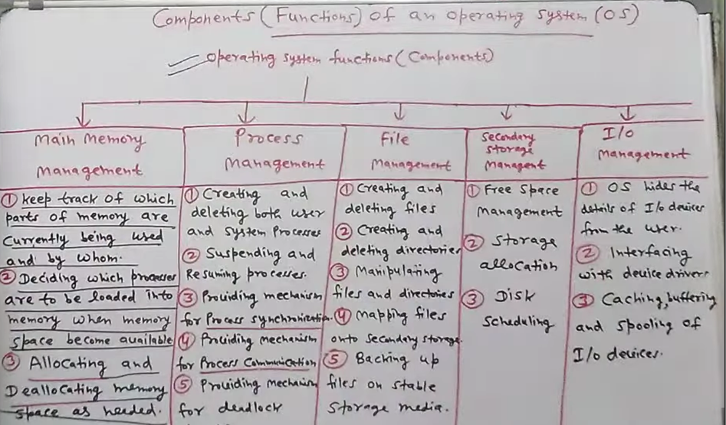

1️⃣ Process Management
The OS controls execution of programs (processes).
Functions
- Creating and deleting processes
- Suspending and resuming processes
- CPU scheduling — deciding which process runs next
- Synchronization between processes
- Inter-process communication
- Deadlock detection & handling
👉 Ensures multiple programs run smoothly without conflict.

2️⃣ Main Memory Management
OS tracks and manages RAM usage.
Functions
- Keeps record of memory usage
- Tracks which parts are free/used
- Allocates memory to processes
- Deallocates memory when done
- Loads programs into memory
👉 Prevents memory conflicts and waste.

3️⃣ File Management
Controls storage and organization of files.
Functions
- Creating/deleting files
- Creating/deleting directories
- Mapping files to storage
- File protection
- Backup management
👉 Maintains organized data storage.

4️⃣ Secondary Storage Management
Manages disks and storage devices.
Functions
- Free space management
- Storage allocation
- Disk scheduling
- Backup operations
👉 Ensures efficient long-term data storage.

5️⃣ I/O Device Management
Coordinates input/output devices.
Functions
- Device driver interface
- Buffering and caching
- Spooling
- Device scheduling
👉 Optimizes communication between CPU and devices.

5) Operating System Services
Services provided to programs and users:
- Program execution
- I/O operations
- File handling
- Communication
- Error detection
- Resource allocation
- Protection & security
These services make computing reliable and efficient.

6) Types of Operating Systems
1) Batch Operating System
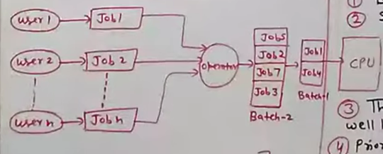
A Batch Operating System is one of the earliest operating system models where jobs are collected, grouped into batches, and executed without direct user interaction. Users prepare their programs offline (historically using punch cards), and an operator organizes similar jobs into batches. These batches are then submitted to the processor for execution.
The key idea is that once a batch starts executing, the user has no control until completion. The system executes jobs sequentially, reducing idle CPU time.
Working Principle
- User prepares job
- Jobs are collected by operator
- Similar jobs grouped into batches
- Batch submitted to CPU
- Jobs executed automatically
Characteristics
- No direct interaction during execution
- Sequential processing
- Suitable for large repetitive tasks
Advantages
- Efficient for repetitive jobs
- Reduces setup time
- Improves CPU utilization
- Simple system design
Disadvantages
- Difficult debugging
- No real-time user feedback
- One faulty job delays entire batch
- Long waiting time
Example Systems
Early mainframe systems such as IBM OS/360 followed batch processing concepts.

2) Multiprogramming Operating System
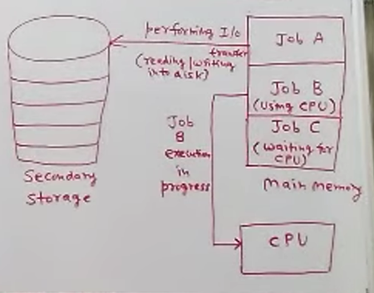
A Multiprogramming OS improves CPU utilization by keeping multiple programs in main memory at the same time. When one program waits for I/O, the CPU switches to another job instead of remaining idle.
This overlapping of CPU and I/O operations ensures better resource use.
Working Concept
- Several jobs stored in memory
- CPU executes one job
- When job waits for I/O → switch occurs
- Continuous CPU activity
Characteristics
- Interleaved execution
- Requires memory management
- Job scheduling essential
Advantages
- Higher CPU efficiency
- Increased throughput
- Reduced idle time
Disadvantages
- Complex scheduling logic
- Requires advanced memory management
- Not fully interactive
Example Systems
Many early UNIX-based environments used multiprogramming concepts such as UNIX.

3) Time Sharing Operating System
A Time Sharing OS allows multiple users to share computer resources simultaneously. Each user receives a small time slice (time quantum). Fast switching between users creates the illusion that each user has a dedicated system.
This model emphasizes interactive computing.
Working Concept
- CPU time divided into small slices
- Users served in rapid rotation
- Immediate response to commands
Characteristics
- Multiuser environment
- Interactive execution
- Fair CPU allocation
Advantages
- Reduced waiting time
- Improved user interaction
- Efficient resource sharing
Disadvantages
- Higher overhead due to switching
- Security concerns
- Performance depends on load
Example Systems
Modern time-sharing environments include Linux multiuser systems.

4) Multitasking Operating System
A Multitasking OS enables a single user (or multiple users) to run multiple applications concurrently. Tasks are divided into small units and executed using time slicing.
This is common in personal computers.
Working Concept
- Tasks share CPU time
- Rapid switching between tasks
- Simultaneous application execution
Characteristics
- Interactive processing
- Task prioritization
- Background operations
Advantages
- Increased productivity
- Efficient CPU use
- Smooth application switching
Disadvantages
- Heavy memory usage
- Possible slowdowns with many tasks
Example Systems
Desktop multitasking systems like Microsoft Windows use this model extensively.

5) Multiprocessing Operating System
A Multiprocessing OS uses multiple CPUs within a single computer system. Tasks are divided into subtasks and processed concurrently, improving performance and reliability.
Working Concept
- Multiple processors share memory
- Tasks split into parallel subtasks
- Concurrent execution
Types
- Symmetric multiprocessing — equal CPU roles
- Asymmetric multiprocessing — master/slave control
Advantages
- Faster processing
- High throughput
- Reliability (CPU redundancy)
Disadvantages
- Complex system design
- Expensive hardware
- Synchronization challenges
Example Systems
Enterprise-class multiprocessing environments include Windows NT servers.

6) Distributed Operating System
A Distributed OS connects multiple independent computers to act like a single system. Each node has its own CPU and memory, but they communicate through a network.
Users experience a unified computing environment.
Working Concept
- Networked computers cooperate
- Resource sharing across nodes
- Transparent communication
Models
- Client–Server
- Peer-to-peer
Advantages
- Resource sharing
- Scalability
- Fault tolerance
Disadvantages
- Network dependency
- Security concerns
- Complex coordination
Example Systems
Distributed computing platforms often run variants like Ubuntu.

7) Real-Time Operating System (RTOS)
A Real-Time OS guarantees task execution within strict timing deadlines. It is used in safety-critical environments where delays are unacceptable.
Working Concept
- Tasks scheduled by deadlines
- Deterministic execution
- Predictable timing
Types
Hard Real-Time
- Deadline must never be missed
- Used in safety-critical systems
Soft Real-Time
- Small delays tolerated
Applications
- Air traffic control
- Satellite systems
- Industrial automation
- Medical equipment
Advantages
- Predictable performance
- High reliability
- Precise timing
Disadvantages
- Limited flexibility
- Complex design
Example Systems
Industrial RTOS platforms include VxWorks.

7) Operating System Structure
OS structure defines how components are organized.
Simple Structure
- All functions in single layer
- Fast but hard to maintain
Example: MS-DOS
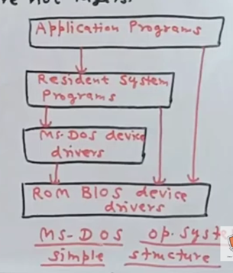

Layered Structure
- OS divided into logical layers
- Hardware at bottom → UI at top
- Easier maintenance
Example: UNIX
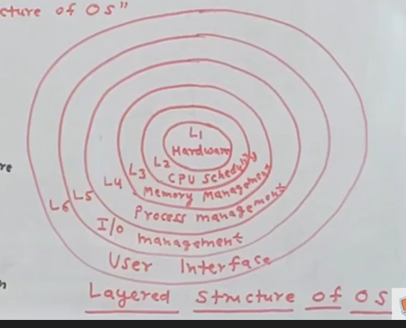

8) System Calls
System calls allow programs to request OS services.
Categories:
- Process control
- File management
- Device control
- Information retrieval
- Communication
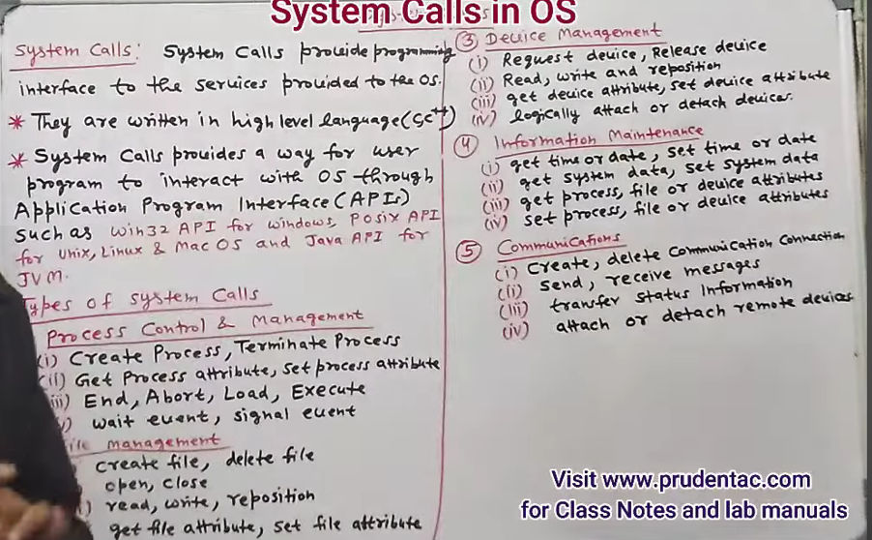

9) System Programs
Provide environment for development and execution.
Functions
- File manipulation
- System status reporting
- Programming tools (compiler, assembler, debugger)
- Program loading/execution
- Communication utilities

10) Re-entrant Kernel
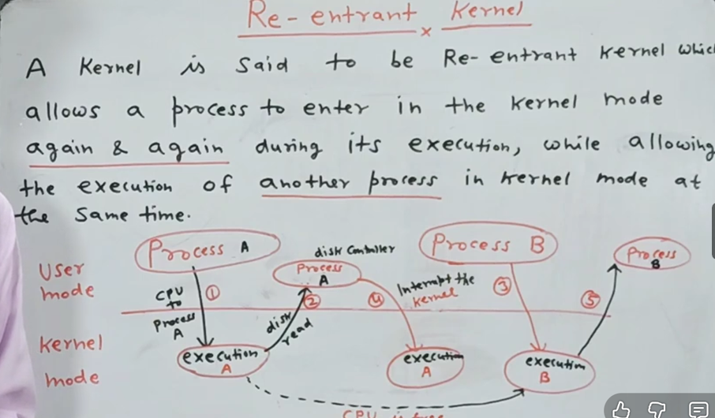
A kernel is re-entrant when multiple processes can safely execute kernel code simultaneously.
Benefits
- Efficient multitasking
- Safe concurrent execution

11) Monolithic vs Microkernel
Basis | Monolithic Kernel | Microkernel
Structure | All OS services inside one large kernel | Only core services inside kernel
Kernel size | Large | Small
Performance | Faster | Slightly slower
Stability | Low — crash affects whole system | High — faults isolated
Flexibility | Hard to modify | Easy to extend
Security | Less isolation | Better isolation
Example | Linux | QNX
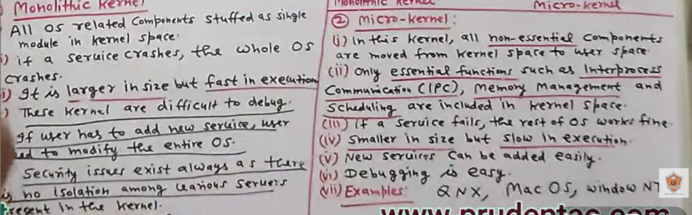
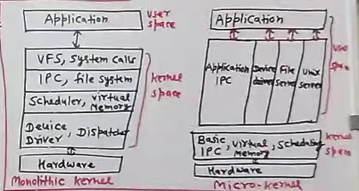

12) Generations of Operating Systems
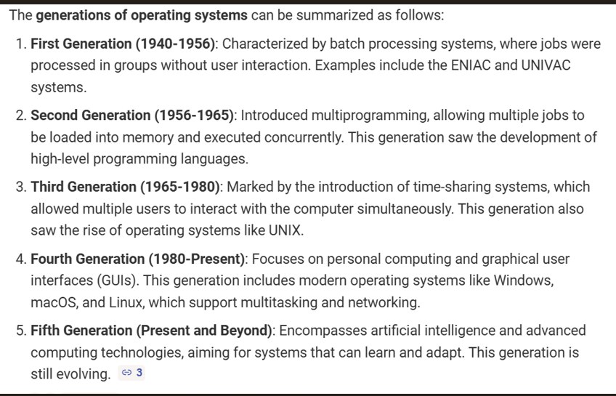

13) Process Management Overview
Ensures orderly execution of programs:
- Process creation & termination
- Scheduling
- Synchronization
- Communication
- Deadlock handling

